Case Study 4

Title: Development of password strength checker using HTML,CSS.
Program code:-
<!DOCTYPE html>
<html lang="en">
<head>
<meta charset="UTF-8">
<meta name="viewport" content="width=device-width, initial-scale=1.0">
<title>Password Strength Checker</title>

<style>
* {
margin: 0;
padding: 0;
box-sizing: border-box;
font-family: "Segoe UI", Arial, sans-serif;
}

body {
min-height: 100vh;
display: flex;
justify-content: center;
align-items: center;
background: #f4f6f8;
color: #1f2937;
padding: 20px;
}

.container {
width: 470px;
background: #ffffff;
border-radius: 20px;
padding: 42px;
box-shadow: 0 20px 55px rgba(0, 0, 0, 0.10);
border: 1px solid #e5e7eb;
}

/* HEADER */

.security-icon {
width: 58px;
height: 58px;
background: #fff1f2;
color: #b91c1c;
border-radius: 15px;
display: flex;
align-items: center;
justify-content: center;
font-size: 27px;
margin-bottom: 22px;
}

h1 {
font-size: 28px;
color: #111827;
margin-bottom: 8px;
}

.subtitle {
color: #6b7280;
font-size: 14px;
line-height: 1.6;
margin-bottom: 30px;
}

/* INPUT */

.input-label {
display: block;
font-size: 13px;
font-weight: 600;
color: #374151;
margin-bottom: 8px;
}

.password-box {
position: relative;
}

.password-box input {
width: 100%;
height: 52px;
padding: 0 48px 0 15px;
border: 1px solid #d1d5db;
border-radius: 9px;
outline: none;
font-size: 15px;
transition: 0.2s;
}

.password-box input:focus {
border-color: #b91c1c;
box-shadow: 0 0 0 3px rgba(185, 28, 28, 0.08);
}

.toggle {
position: absolute;
right: 14px;
top: 50%;
transform: translateY(-50%);
border: none;
background: transparent;
cursor: pointer;
font-size: 17px;
color: #6b7280;
}

/* STRENGTH */

.strength-header {
display: flex;
justify-content: space-between;
align-items: center;
margin-top: 25px;
margin-bottom: 9px;
}

.strength-header span:first-child {
font-size: 12px;
font-weight: 600;
color: #6b7280;
text-transform: uppercase;
letter-spacing: 0.6px;
}

#strengthText {
font-size: 13px;
font-weight: 700;
color: #9ca3af;
}

.strength-bar {
width: 100%;
height: 7px;
background: #e5e7eb;
border-radius: 20px;
overflow: hidden;
}

#strengthFill {
height: 100%;
width: 0%;
border-radius: 20px;
transition: 0.3s ease;
background: #d1d5db;
}

/* REQUIREMENTS */

.requirements {
margin-top: 28px;
padding: 20px;
background: #f9fafb;
border-radius: 12px;
border: 1px solid #eef0f2;
}

.requirements h3 {
font-size: 14px;
margin-bottom: 15px;
color: #374151;
}

.requirement {
display: flex;
align-items: center;
gap: 10px;
margin: 11px 0;
font-size: 13px;
color: #6b7280;
transition: 0.2s;
}

.check {
width: 20px;
height: 20px;
border-radius: 50%;
background: #e5e7eb;
display: flex;
justify-content: center;
align-items: center;
font-size: 11px;
color: white;
flex-shrink: 0;
}

.requirement.valid {
color: #15803d;
}

.requirement.valid .check {
background: #16a34a;
}

/* MESSAGE */

#message {
margin-top: 22px;
text-align: center;
font-size: 13px;
font-weight: 600;
min-height: 20px;
}

/* FOOTER */

.footer {
margin-top: 28px;
padding-top: 18px;
border-top: 1px solid #eeeeee;
text-align: center;
color: #9ca3af;
font-size: 11px;
}

@media (max-width: 520px) {
.container {
width: 100%;
padding: 30px 25px;
}
}
</style>
</head>

<body>

<div class="container">

<div class="security-icon">
🔐
</div>

<h1>Password Strength</h1>

<p class="subtitle">
Create a strong password to keep your account
protected from unauthorized access.
</p>

<label class="input-label">
Enter Password
</label>

<div class="password-box">

<input
type="password"
id="password"
placeholder="Enter your password"
oninput="checkPassword()"
>

<button
class="toggle"
onclick="togglePassword()"
type="button"
>
👁
</button>

</div>

<!-- STRENGTH -->

<div class="strength-header">

<span>Password Strength</span>

<span id="strengthText">
Not Entered
</span>

</div>

<div class="strength-bar">
<div id="strengthFill"></div>
</div>

<!-- REQUIREMENTS -->

<div class="requirements">

<h3>Password Requirements</h3>

<div class="requirement" id="length">
<span class="check">✓</span>
<span>At least 8 characters</span>
</div>

<div class="requirement" id="uppercase">
<span class="check">✓</span>
<span>Contains an uppercase letter</span>
</div>

<div class="requirement" id="lowercase">
<span class="check">✓</span>
<span>Contains a lowercase letter</span>
</div>

<div class="requirement" id="number">
<span class="check">✓</span>
<span>Contains a number</span>
</div>

<div class="requirement" id="special">
<span class="check">✓</span>
<span>Contains a special character</span>
</div>

</div>

<div id="message"></div>

<div class="footer">
Password Security Checker
</div>

</div>

<script>

function checkPassword() {

const password =
document.getElementById("password").value;

const fill =
document.getElementById("strengthFill");

const text =
document.getElementById("strengthText");

const message =
document.getElementById("message");

if (password.length === 0) {

fill.style.width = "0%";
text.textContent = "Not Entered";
text.style.color = "#9ca3af";
message.textContent = "";

resetRequirements();

return;
}

let score = 0;

// CHECK LENGTH

if (password.length >= 8) {

score++;
setValid("length");

} else {

setInvalid("length");
}

// UPPERCASE

if (/[A-Z]/.test(password)) {

score++;
setValid("uppercase");

} else {

setInvalid("uppercase");
}

// LOWERCASE

if (/[a-z]/.test(password)) {

score++;
setValid("lowercase");

} else {

setInvalid("lowercase");
}

// NUMBER

if (/[0-9]/.test(password)) {

score++;
setValid("number");

} else {

setInvalid("number");
}

// SPECIAL CHARACTER

if (/[^A-Za-z0-9]/.test(password)) {

score++;
setValid("special");

} else {

setInvalid("special");
}

// DISPLAY STRENGTH

if (score <= 2) {

fill.style.width = "30%";
fill.style.background = "#dc2626";

text.textContent = "Weak";
text.style.color = "#dc2626";

message.textContent =
"Your password needs improvement.";
message.style.color = "#dc2626";

}

else if (score === 3 || score === 4) {

fill.style.width = "65%";
fill.style.background = "#d97706";

text.textContent = "Medium";
text.style.color = "#d97706";

message.textContent =
"Your password is moderately strong.";
message.style.color = "#d97706";

}

else {

fill.style.width = "100%";
fill.style.background = "#16a34a";

text.textContent = "Strong";
text.style.color = "#16a34a";

message.textContent =
"Excellent! Your password is strong.";
message.style.color = "#16a34a";
}
}

function setValid(id) {

document
.getElementById(id)
.classList.add("valid");
}

function setInvalid(id) {

document
.getElementById(id)
.classList.remove("valid");
}

function resetRequirements() {

document
.querySelectorAll(".requirement")
.forEach(item => {
item.classList.remove("valid");
});
}

function togglePassword() {

const password =
document.getElementById("password");

const button =
document.querySelector(".toggle");

if (password.type === "password") {

password.type = "text";
button.textContent = "🙈";

} else {

password.type = "password";
button.textContent = "👁";
}
}

</script>

</body>
</html>

OUTPUT:
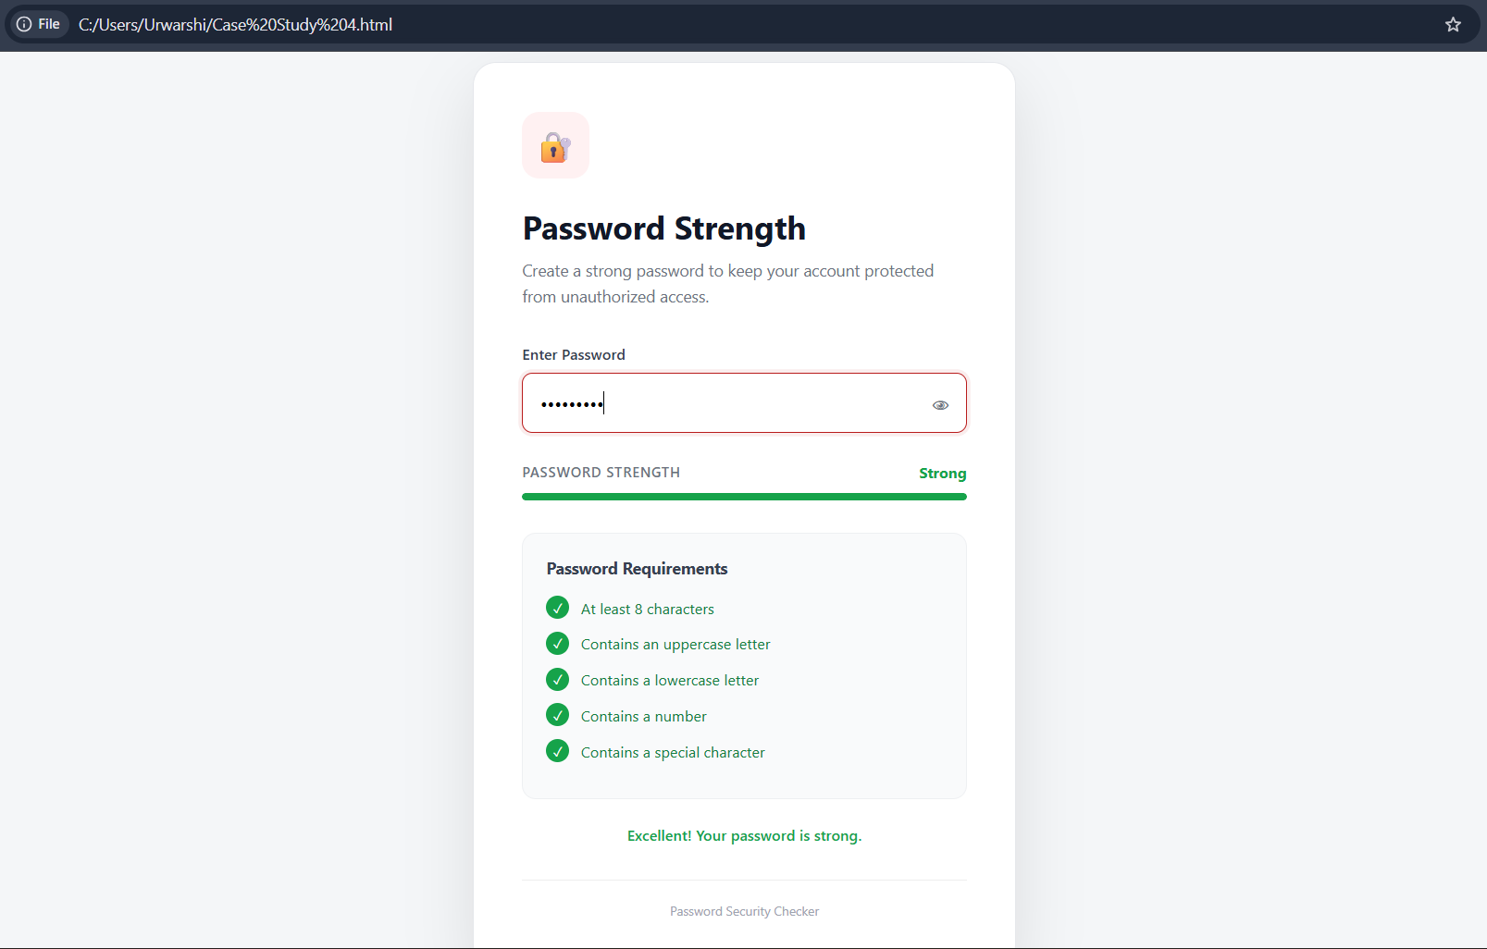

Result/Conclusion:
Successfully developed a professional Password Strength Checker using HTML and CSS that evaluates password strength and displays real-time security requirements.

